Table of Contents.

Introduction

The First Steps of a new Creation

The Engine Menu Introduction

The Game System Creation Windows Explanation

The Character Creation Windows Explanation

The Stages Creation Windows Explanation

The Demos Creation Windows Explanation

Conditions & Functions Explanation

Credits

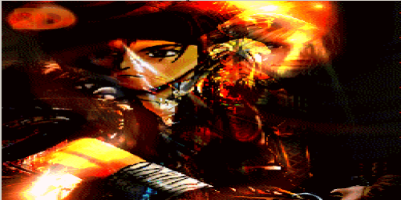

Introduction

The Fighter maker Engine FM2002 (Japanese Version FM2nd) is a software package that was developed by ASCHII and Enterbrain.

This Engine was bought and contributed by Mirage in the year 2002 to the American and European Communities and was newly Translated by MBouza (first Translation in 2002 by Proof58) in the English Version.

The reason why it had to be done this way was the fact that the developers didn’t intended or planned to release the engine outside Japan in a later or on the same date as the release in Japan at all.

With this engine you are able to make 2d Fighting Games similar to the Street Fighter and King of Fighters games.

Though it contents many commands, which gives you the possibility to make even better games then those.

This Tutorial is based on this Engine and should be a help to all those creators out there who would like to learn the engine so that they can make their own 2d Fighting Games in a very easy way.

In the following pages you will be able to find the basic and later the advanced techniques that will assist you through the world of the 2d Fighting Games creation.

You will learn from the beginning how to start a project by creating a concept, understanding the commands and the functions of the engine, as also how to make your own stages, demos, characters and of course game systems which are the so called game scripts by making some basic and advanced examples.

Please notice that some of the sections on this Tutorial will be updated once in a while until we will be able to cover all the possibilities of creation with this Engine.

The First Steps of a new Creation

A Creation is:

1) The event that occurred at the beginning of something.
2) The act of starting something for the first time; introducing something new
3) The product of human creativity, something that has been brought into existence by someone.

There are so many different lines we could write about creation that it would take a lot of pages to list them all. The reason for that is that the definition “Creation” depends partially on what was created through the Idea of our Human Creativity, which caused this creation to happen.

Even we all in our community are making games, some differs from each other due to the fact that some characters, stages, demos or even scripts, are based on own graphics which was created by the game maker him-/herself by drawing the graphics, or by using other peoples creations (sprites from known games) by taking already finished graphics.

Though even if the creation part differs, the goal is the same!
Making a New Game, based on our own Creativity!

Concepts for new games can be made through:

- Brainstorming (sitting or chatting around with one or more same-minded friends talking about different stuff which would be cool to have in a game)

- Fan based (Based on stuff like other games, comics, movies, books,
Stories, which gave you the idea to use the characters or the story for your game).

Both Methods can of course be used for features after the base concept is set already or other stuff too. Though there are some main “smooth” steps, which you should follow if you want your project to be successful.

- The first base if you intend to have a story in the game is to:
- Think about what type the story should be and in what kind of places it will play
- Think about who is going to be involved in the story and why.

- Write everything down; make lists of contents and features. See after that if something should be changed or not (in a project always changes something no matter if it’s in the beginning or in the advanced progress).

- After that, start step by step by making first of all the script for your game (Your Game System actually).

- Create than your stages, demos and characters (you can do those partially at the same time or finish the stages first and go to the other parts after. Though it’s your decision!)

Some people tend to start with the advanced skills or extras first, instead of finishing the base for their games.

Though it’s actually better if you make a base where you can build up first, so that the game can “stand” somewhere before you go further.

I was about to share some more of my knowledge about Concepts and Methods which are used in the Gaming Industry but I dropped this idea due to time issues and also because it didn’t seemed to be too much of a importance for this Tutorial and/or type of Engine.

The Engine Menu Introduction

Ok now! We have the engine but…. How are we going to use it?

Well the first step you should make on ANY software (if you don’t want to “eat” the knowledge outside the manual) is to browse the menus first to see what kind of functions are accessible and what these functions do.

So let’s take a closer look on those menus in FM2002.
After you started your KGT2nd_EDITOR.exe the main window will appear and you will be able to see the following menu:
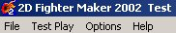

As you can see, there are four Menu Sections there.
Each one of those contents one or more functions in it that are available to you after you clicked one of the main menus.

Under the Menu File are the following functions to find:
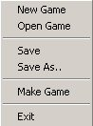
The Function New Game:
Starts a New Project and asks you for the projects name.
(Notice that this name will stay and will appear in the game as the title on the upper section of the window in the window modus!).

The Function Open Game:
Opens a windows explorer window so you can search your saved project and open it from there. (Notice that compiled games actually can’t be opened on the editor)

The Function Save:
Saves the last edited state of your project after you made changes and clicked on it.
(Tip: Save often! Better to save every time you made 2 – 3 changes instead of losing all the changes after you made 10-20 different changes or created something new)

The Function Save As.:
It let’s you save your project under an other name after you chose one and wrote it on the field of the window, which appears after you clicked on this function.

The Function Make Game:
It compiles your project and makes a playable game out of it.
(Notice that all the options in your project like demos settings, character and stages settings has to be finished before you compile your game. Otherwise it probably won’t even start)

The Function Exit:
It closes the engine and goes back to your windows.
(Notice that unsaved changes will get lost if you close the engine without saving first)

The Menu Test Play:
It gives you the opportunity to test your stages, demos and characters before you compile your game. The Following Options are there to find.
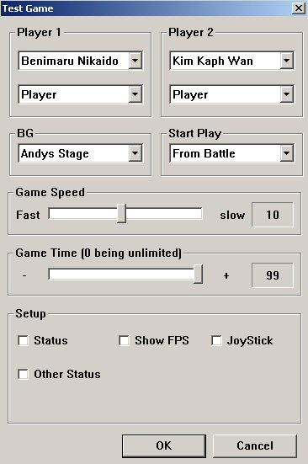

The Options Player 1 and 2:
You can choose one of the characters you have already added in the engine and want to test from the list after you click on the arrow on the right side of the name.

The fields under the Players name 1 and 2:

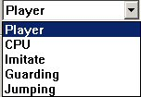
You can click on the arrow like in the player options to open the list.
As you can see there are different options, which can be set there.

Player:
That means that you or a friend due the testing phase will control the selected character.

CPU:
The computer will control the character in case he/she has a programmed AI already. Otherwise it will just stand there doing nothing.

Imitate:
The character is imitating what the other character does by doing exactly the same moves at the same time.

Guarding:
The enemy character is guarding every attack you make or at least it tries to.

Jumping:
The enemy character is jumping the whole time.

Other Fields

BG:
Under this option you can chose a Stage you have added in your game already for the testing.

Start Play:
Under this option you can find two different possibilities:
1) From Battle
2) From Title

If you chose from Battle, the test game will start immediately on the first round.
If you chose from Title, the test game will start with the opening that you have set up in the basic of your script. If it won’t find any, it will start on the title screen you have set up this before too like every demo) directly and makes you able to go through the select screen before you start playing.
To be able to use the select screen demo, it has to be set up first and at least one of your characters has to be added in the engine.

Game Speed:
Through this option, can set the speed of your test game.
The default value is 10 (Medium speed); the maximum and slowest value is 20 and the minimum but fastest is 1.

Game Time:
The Game Time option gives you the possibility to set the test game time from 0 (Unlimited) to 99 no matter if you want the time to be 10 or 53(example).
The Game Speed you set before does not affect the counting speed.

The Status Option:
If you check this option, you will be able to see the frames around the bodies of the characters, as also the amount of health, hit junctions when they are triggered, stances and everything else you “programmed” in your character.
As example it could look like this:
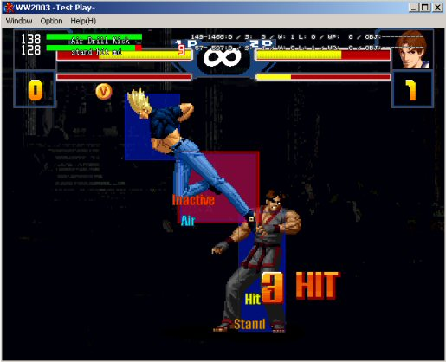
Amount of Health. | Attack Name of player one. | Status of Player two (Hit junction in this case). | Axis of height and wide. | Draw, Win or Lose. |Object which is shown (in this case none). | Activity of the characters and stance.

The Show FPS Option:
Actually it defines how many pictures e.g. frames one second of video or audio contains, normally used acronym for framerate (Frames Per Second).
Human eye can't see picture changes after the framerate is more than ~24fps.
In American TV system NTSC the framerate is appx. 29.97fps and in European PAL system the framerate is 25fps.

The Joystick Option:
Check this option if you want to play your test game with a joystick instead of the keyboard. You can still change this option under the in game options if you change your mind about using a Joystick.

The Option Other Status:
Actually nothing special. I tried to use it out of curiosity sometime but it didn’t show me anything.

I guess that even it didn’t got translated well for now or you need to do something special like have a special condition appearing there in the test game so that the status of this option can be shown.

Otherwise just use the Status Option, which was mentioned above.

The Menu Options:
There are 7 different
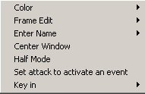

The Colour Option:
Under this option you are able to change the colours of your editor like the background colour of the character, stage and demo creation window and the colours of the frames that you are drawing around the body of your character (Attack Frame, Strike, Doing and so on…).

The Frame Edit:
There are two settings there available. Corner and Centre.

- Corner Setting:
It starts the frames you are drawing around your character (Attack frames as example) on the upper left corner of the Character sprite.

- Center Setting:
It starts drawing the frame exactly where you are pointing with your mouse starting with the edge of the frame there (Centering).

Enter Name:
Only one setting with the name “Modify Name” which can be checked or unchecked, though I never saw any difference to anything either it was checked or not. If someone of you find something about out just let me know so that I can add it in this section.

Center Window:
It should actually Center the character, demo and stages editor window, though It didn’t worked no matter where I moved the lines of the window.

Half Mode:
If this option is checked then the editor window where you are making your characters, stages and demos, turns from the original size to the half size (Zooms out).
This option is very helpful when it comes to large images for stages and demos.

Set attack to activate an event:
I didn’t tried this setting out yet, but I’m quite sure that this option has to be set when you intend to make a extra mode for your game like a training or other mode.
It should actually make it possible for you to activate the extra mode after the event you setup for this purpose triggers through the attack that was programmed for it (Like the Training Mode in the SCWU Game).

Key In:
Under this option you can find a list of commands and the key configuration for them.

This option is very helpful to creators that like to work with Hotkeys instead of wandering with their Mouse through the options.

If you want to change the configuration of a function there just click on it and after that a small message will appear asking you to tap on the new key which should be set for this function or to tap on ESC to break up the modification you want to make.

HELP

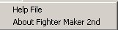
Help File:
If the original help file would be good implemented and translated, you would be able to open it by clicking on this option.

About Fighter Maker 2nd:
Under this option you can get information’s about the Engine Version and the Company names and copyrights.

Well since we went through the Engine Menus and their options by explaining those, let’s take a look further to see what this engine is capable off.

The Creation Windows

The Creation Windows content many different other window, which holds many, functions in them and are very helpful.

Here a small view of the windows and their functions:

The Game System:
Under this window you can find all the options you need to be able to make a unique system and make it look the way you want.

Characters:
Under this window you can find all the options which ables you to make Characters for your games.

Stages:
Under this window you can make your stages.

Demos:
Under this window you can make all kind of demos you want your game to include.

The Game System Creation Windows Explanation

The Game System Windows looks like this:

Every window of those has parts that are needed to run a game or to play a game smoothly like the options of the basic window here. So let’s see what those functions do.
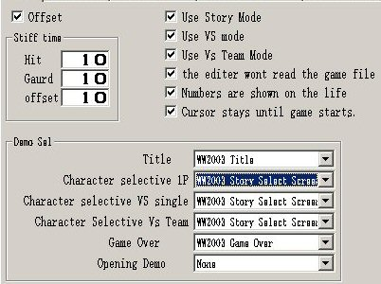

The Offset Function:
I wrote the definition of the offset and also the definitions of every programming word which needed a definition to understand what it is.

Definition: An Offset is the distance from the beginning of a string to the end of a segment in that string.

Definition: A String is a list of characters, usually implemented as an array.
Informally a word, phrase, sentence, etc. Since text processing is so common, a special type with sub string operations is often available.

Definition: An Array is a set of items that are randomly accessible by numeric index.

Definition: A Segment is the substring of a pattern delimited by two don’t cares or one don't care and beginning or end of the pattern.

Definition: A don’t Care is a special symbol which matches any other symbol of a given alphabet. Definition: A Pattern is a finite number of strings that are searched for in texts.

Definition: A Text is a list of characters, usually thought of as a list of words separated by spaces.

(A Very easy explanation for those who doesn’t want to understand what I wrote above)

The Offset is the space between 2 hits that collides to each other at the time your character and the enemy attack at the same time.

If this field is checked, the game tries to correspond to the value you can set in the field under the option Stiff Time with the name Offset and counts the time you set there before another collision like this can occur again.

The Hit and Guard fields are pretty much the same except of the fact that they will work no matter if you checked the offset option or not.

The Hit value counts the time you entered between hits and the Guard is doing the same for Guarded attacks.

Example: You entered the value 5 to hit, the game will count to 5 before you can hit again. You entered the value 5 to Guard option then the character won’t be able to guard before the count to 5 is over.

Use Story Mode, Use VS Mode and Use VS Team Mode: are self-explanatory.
If you check those fields all those modes will be available for you in the game after you set the conditions for your characters. If none of those fields are checked an error will appear in your game letting you know that none of those modes are set and so the game won’t be able to play. Please notice that in the field Gameover, you have to select your Continue Demo (mistranslation).

The Editor won’t read the Game File:
If checked, then this function prevents a compiled game from being opened with the editor after the compilation.

Numbers are shown on the life:
If this option is checked then the amount of life is shown in the game as numbers on the left side of the lifebar which will be shown over the head of the characters but only if the setting on the story mode option (Characters window after you added a special fight) is set on Show Life and the characters will be in a match with more than 2 fighters.
Otherwise it will show only the decreasing of the lifebar as default.

Cursor stays until the game starts:
If checked then the Selection Cursor at the title will stay active until the game starts or a few seconds, otherwise it would go directly on the next screen without any “wait” and it won’t appear in the beginning before you moved it (won’t be visible).

Demo Sel (Selection)

- Title:
Select the Demo you want to use as your Title Demo here.
- Character Selective 1P:
Select the Demo you want to use as your Story Mode
Selection screen here.
- Character Selective VS Single:
Select the Demo you want to use as your VS Mode Select Screen here.
- Character Selective VS Team:
Select the Demo you want to use as your VS Team Mode Select Screen here.
- Game Over:
Select the Demo you want to use as your Game Over Demo here.
- Opening:
Select the Demo you want to use as your Opening Movie here (appears before the Title Demo)

The Basic Script Window

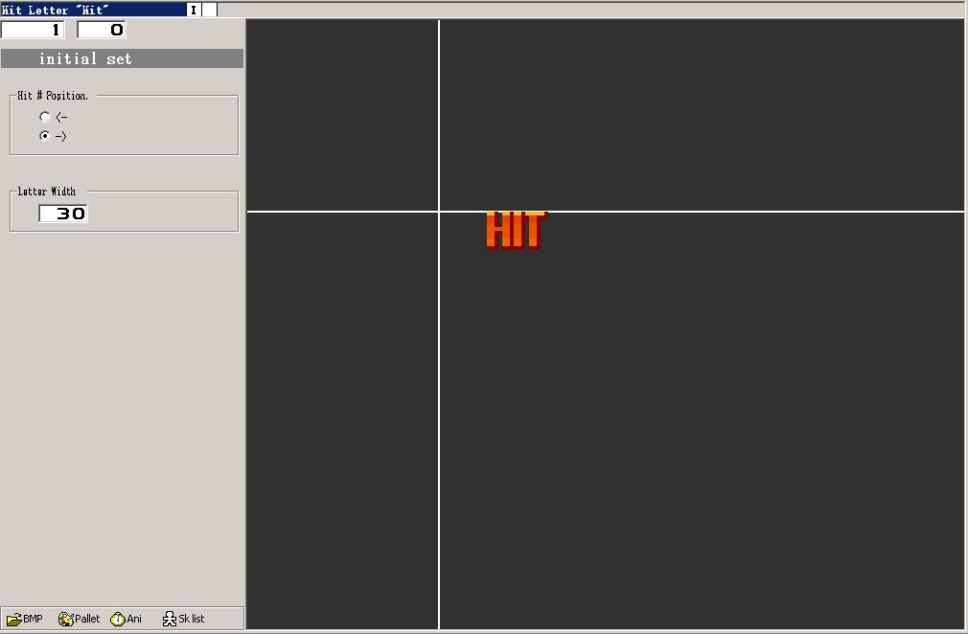

In the basic script window you have the following options:
Skill fields, Script images window,
Bmp folder, Palette option, Animation Window,
and the Skills List.

The Skill Fields:
In this fields you are programming the reactions of a character, adding images which should saw as a animation, programming effects, conditions, hit junctions and everything else you want to be triggered through the game system.

Script Images Window:
This is the place where you can see the images you added in your stage, character or demo.

BMP Folder:
Through this folder you can add images for your characters, stages and demos in the engine.

The Palette:
Through this Palette you can change the colours of your stage, demo or character.
It gives you also the opportunity to make up to 8 different Colours for your characters.

Animation Window:
When you activate it, it gives you the opportunity to see the animation of the skill you have chose in the background no matter if it’s a demo, stage or character.

The Skills List:
On this list you can see all the skills you made for your characters, demos and Stages.
You can either pick one you want to check out or work on or even switch between two skills per one click.

The Hit Junctions Window
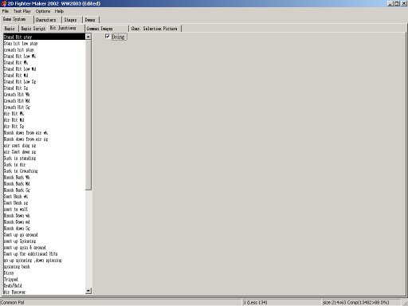

In this window you have to add all the hit junctions you want to be available in your game.
Hit Junctions are actually the Hit Reactions of a Character or Object.
No matter if it’s a character or a Item or even a Stage or Demo, if you want something to react on something in your game, just make a hit junction in your system and apply this in the appropriate hit junction skill of the object, character, stage or demo you want to have it.

The Doing option

This Option if checked, corresponds with the Guard skills of a fighter and allows the fighter to get hit by ignoring the Guard Status you have set in the hit junction.

The Common Images Window
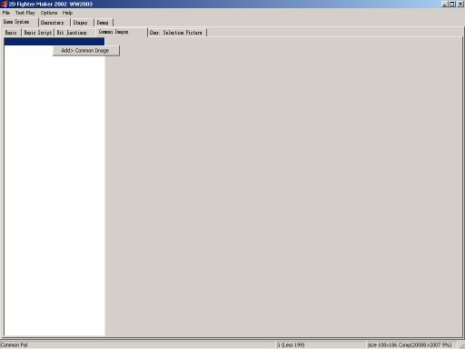

In this window you can add images you would like to use for your characters like items and character sprites for some particular stuff.
Actually all you need to do is chose the option Add Common Image and click on it to add one.
After that you can go to your character common images screen and chose due to the number, one of the sprites you have added in the different skills of your character before.
I will explain Common Images a bit more lately in our chapter about the Character Creation.

The Character Selection Positioning Window

In this window you can position the following things:
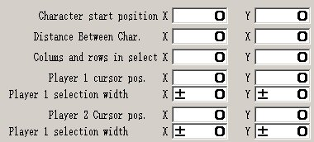

The Character Start Position:
The position of the first character selection field on your Select Screen has to be set here.
You can set it by writing the values you need in the X, Y fields.

The Distance Between the Char position:
The distance between the character selection fields has to be set here.
Set the X, Y values so the cursor shows right when you move over the fields by jumping to the exact position of the next field.

The Columns and Rows in Select:
Here you can set how many rows and columns your select screen will include.

The Player 1 Cursor Pos.:
On this option you can set the Cursor position in the Select screen fields you added.

The Player 1 Selection Width:
On this option you can set the width of the select icons/pictures (like the character faces), so that the cursor will jump from the one field to another appropriate instead of jumping to the wrong position.

The Player 2 Cursor Pos.:
Same like the Player 1 (check above)

The Player 2 Selection Width:
Same like the Player 1 (check above)

The Character Creation Windows Explanation

After you right clicked on the white field of the window you will have 2 different options:

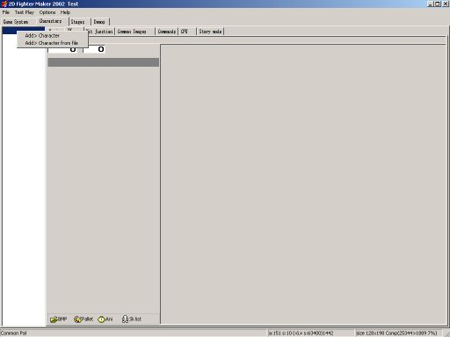

Add Character:
Chose this option if you want to start a new character.
Write the name in the field your character should have and click on ok.

Add Character from File:
Chose this option if you have a finished or unfinished characters in file form that can be imported in your game.
Then just choose the file from the folder you have it saved and add it by clicking open.
Notice that character files from compiled games can’t be imported (normally).
The Character Basic Window
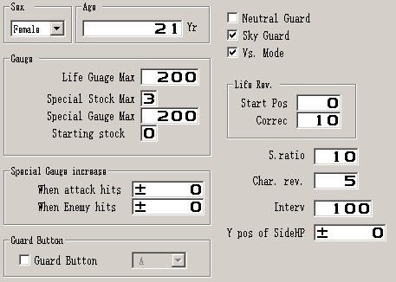

The Sex (Gender) Field:
You can chose one of the 4 different listings if your character is a male, female, both (like some Amphibian characters) or none.

The Age Field:
Actually self-explanatory.
You can write a value that will be the age of your character in this field.

The Neutral Guard Box:
If checked the Character will be able to block attacks even if they are connected in a combo for around every 1,5 – 2 Seconds.

That means that if you launch an attack between these spaces of those seconds you will still be able to hit the character. Otherwise your attack will be blocked no matter if it’s a high or low attack.

If unchecked then the character will never block by itself except if you use a Guard move at the time your enemy attacks you. In case of a NPC it depends on how it is programmed.

The Sky Guard Box:
If checked, the character will be able to use block moves on the air.

The VS Mode Box:
If checked your character will be available in the VS Modes (Single or Team), if not it won’t be available on those modes of the game.

The Gauges Options

The Life Gauge Max Field:
In this field you write the amount of Health Points your character should have maximum.

That means that if you give it the value 200 like in the Image above, your character will have exactly 200 Life Points which will be reduced by each attack that hits this character until it reached the amount of Zero.

After this amount turned to zero, the character will be defeated and you will lose a round (or win a round if the enemy turns to zero after he/she lose all his/her Health Points first).

The Special Stock Max Field:
In this field you can set the amount of Super Energy Bars a Character can have maximum.

The highest number you can enter there is 9.

If you give it a value of zero, then the character won’t be able to use the Super Bar and so it won’t be able to charge energy or be able to do any super moves if they are programmed to use the Super Bar.

The Special Gauge Max Field:
It works exactly the same way like the Life Bar Gauge with the difference that the 200 Super
Energy Points you can see on the image above would fill one Bar from the 3 in the special stock max field.
That means that you need 200 points per super bar.

This way you can control how fast the energy bar can be filled through the basic window since the more energy is needed the more your character will have to gain so it can fill his/her super energy.

Though the speed the super bars fills depends on how much energy points you will add in the charge move of your character (in case it has one) also. So the more you are adding the faster it will fill its bar.

The Starting Stock Field:
In this field you can add the value of the super bars you want your character have at the beginning of a match.

That means if the max of your stock field is 3 (like in the image above) and you have it to zero,
Your character will start the round with no super energy.

If you add a value in the field which is higher then the 3 Stocks Maximum we set on the Special stock max field, (for example 4) then after the “extra bar” was used once it will be ignored and your character will be able to gain only the 3 levels of super bar we set in the Stocks maximum field before.

The Special Gauge Increase Options

The Gauge Increase options can be used in a game or not (your decision). Some games are using a Charge move that increases the super energy at the time a character launches this move.

This way your character would increase the amount of his/her super energy by using a command based move (manually method).

Though with the special Gauge increase options you can increase the amount of super energy your character has automatically.

Here are the two methods:

When attack hits:
The value that you add in this field will be the amount of super energy you will gain every time your character will hit the enemy successfully.

When enemy hits:
Exactly the same function like the “When attack hits” with the difference that you gain super energy only when you get hit by the enemy.
Otherwise you won’t get any.

You can also use both fields at the same time, though I wouldn’t recommend it since it would make your character able to launch a super attack every few seconds.

The Guard Button Option

Guard Button:

Under this option you can set which button you would like to assign as the Guard Button in case that you want to make a game in which the characters are able to block attacks only by pressing a button.

You have one of 6 different buttons to choose from A to F.

This button can be any button of your keyboard or Joypad since it’s customisable through your game options.
The Life Rev. Options

Life Field:
This is the Y coordinate Value, which corresponds to the start position of a life-sidebar.
The life-sidebar can be activated under the Basic Game Option and will show in a Team VS Mode or a Story Mode in which more than one characters or enemies are on the screen at the same time.

Correction Field:
The amount of damage the enemies can do against you after you reached a percentage of your hit points can be controlled by adding a value in this field.

That means that after your characters HP has decreased to this amount, the enemy will make less damage then before.
Example: Your Value is set to 10 (10%), then after your character has only 10% of his/her Health Points left, the enemy won’t be able to make as much damage to your character like before since your character will have a increased defence.

S.Ratio:
When you are guarding and get hit then the designated value plus the power percentage is the save.

Character Revision:
If checked, it will “ignore” the amount of damage added in a attack frame and continue with the value you added in this field by decreasing it for the further attacks.
This function will trigger only in a combo after the first attack hits and only if this attack reached a value higher than the one in the field.

Interv.:
This is the standard value a character will use, as it’s standard range when it comes to the short and long-range pattern.

Y Pos of Side HP:
The value you will set in this field is the Y Position of the side hp your character will use if the option for the side HP is set.
That means that the higher the value the higher the Side Lifebar will appear on the screen (over your head).
The Character Skills Window (SK)

This is the window in which you are creating your character skills like basic, special, super moves as also adding common images; hit junctions, effects and more:
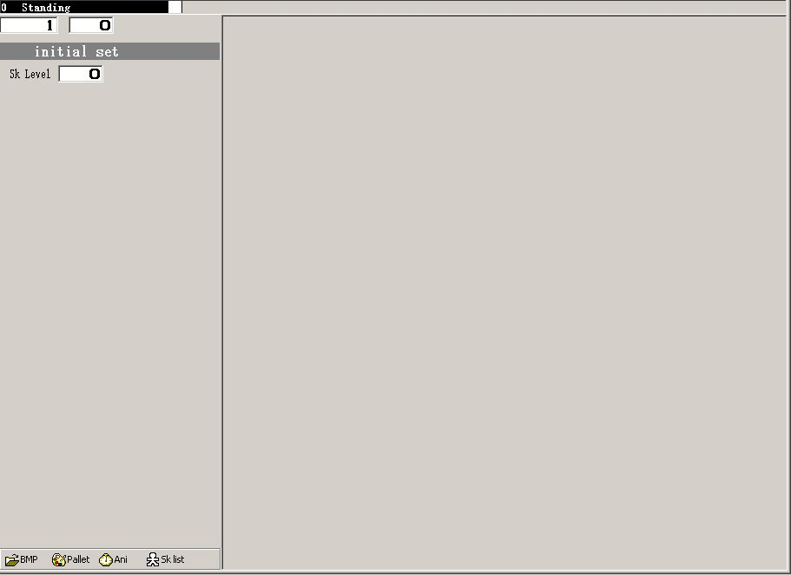
On this view you can see only the skill you have pointed at the moment like the default we can see on this screenie, which is the Standing skill.
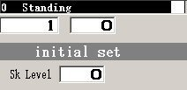
The fields under the skills name helps you to change between the skills and the positions of the skills fast and comfortable by increasing the number like we can see on this Screenie:

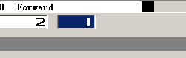

Under the Initial Set Option you can set the skill level of your skill by giving it a value which is Zero as default for basic moves like the standing move on the Screenie and 10 for other skills like punches and kicks.

To vary the connectivity of the skills you can give them different values like (example) giving the light punch an 11 and the hard punch a 12, while you give a special move a 13.

In the low section of your window, you have 4 more options (the same as in the script, stages and demo skill windows), which are the Bmp folder, Palette option, Animation Window,
and the Skills List.

BMP Folder:
Through this folder you can add images for your characters, stages and demos in the engine.

The Palette:
Through this Palette you can change the colours of your stage, demo or character.
It gives you also the opportunity to make up to 8 different Colours for your characters.

The only difference between this Palette option and the ones under the stages, demos and script one, is that this one has more options.

Animation Window:
When you activate it, it gives you the opportunity to see the animation of the skill you have chose in the background no matter if it’s a demo, stage or character.

The Skills List:
On this list you can see all the skills you made for your characters, demos and Stages.
You can either pick one you want to check out or work on or even switch between two skills per click by choosing one from the list.

The Character Hit Junctions Window

As you can see in the following Screenie, this hit junctions window differs from the one we saw in the Script Window explanation.

The reason for that is that this Window contents 3 sections:

The Script Hit Junctions Section (Hit Junction), The Character Hit Junctions Section (Allotment) and the Sparks Section (Sparks).

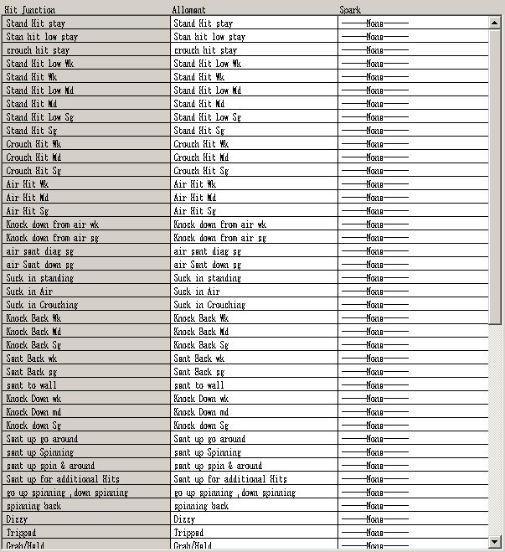

The Script Hit Junctions Section:

This section is inactive under this menu since it has to be set under the script hit junctions window and it’s only viewable here so the creator can match the character hit junctions by choosing them at the right positions so that no problems can occur by choosing a wrong one.

If you chose a hit junction who doesn’t match to the script one it will still work but with glitches, which could possibly crash your game since the script will react on a different way then the character.

The Character Hit Junctions Window (Allotment):

On this section you can set the hit junctions you made in the skills section of your character.
To make your game work smoothly it would be good to set them at the right positions and also name them like the ones you have in your script to prevent mistakes and glitches.

The Spark Section:

Here you can set sparks to your hit junctions by choosing a skill which contents some after you made them in the skills section of your character.

The Common Images Window
In the common images window of your script (see scripts window explanation) you can add as many common images as you want/need for your project.

In the Characters Common Images Window you can set the images you want for those by increasing the number in the first field by click, and set the X, Y coordinates through the other two fields like on this screenie:
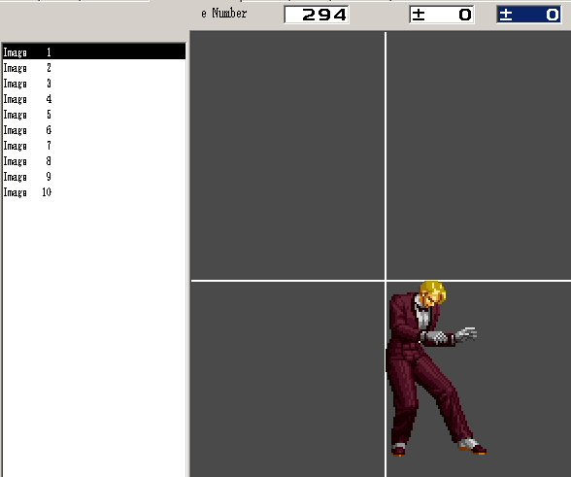

In the right part of your window you can see and set the position of the image you chose, while on the left side you can see how many images you added in the Scripts Common Images Window and select the one you would like to work on it’s axis (X, Y Coordinates).

Common Images can be character sprites, items sprites, even parts of a stage or anything else you would like your character to have to “deal” with.

The Common Images can be used for Special Attacks, Super Attacks, Grab Moves and many other different things.

The Commands Window
The commands window is the place where you add all the commands to the moves your character has.

On the left side of the window is the list, which contents the characters you added in the characters window.
In the middle window you can see the skills you added and set a command for.
On the right side of the window you can see the commands according to the skill you have clicked on.
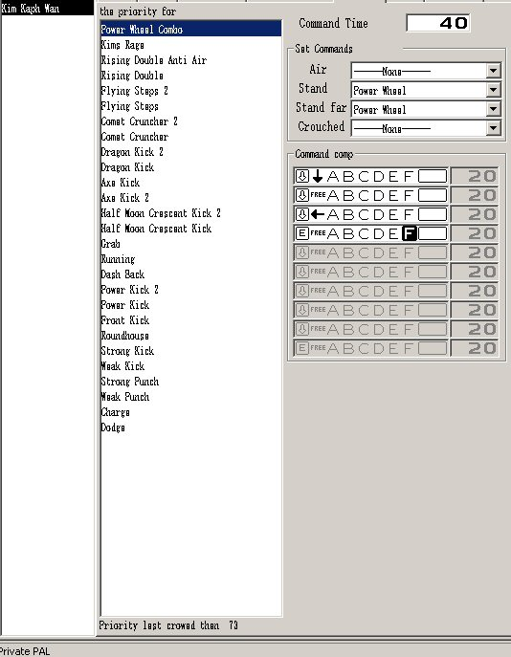

To add a new command just right click with your mouse on the middle window and then click on the option Add Command.

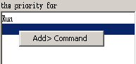

Usually the easiest commands to launch in a game are the basic ones like jumping, walking for- backwards and so on….
Those easy commands should be on the bottom while the difficult ones should be set on the top of the list like you can see on the Screenie on Kim Kaph Wans list above (dodge, charge and the basic attacks are on the bottom while the super moves are on the top).

Actually the Command Window is self-explanatory but still a mystery when it comes to some options of it to many creators.

So let us check the options one after another to see what we exactly can set here:

Command Time:

In the Command Time field you can set a value, which will correspond to the time a player will have to trigger this command in the game.

Since the engine counts the value 100 as 1 second but a player (believe it or not!) needs actually less then a second to trigger one move, is the most common way to set the basic skills like light punches, kicks, charge moves etc. to 10, special moves between 20 and 30 and super moves around 40 – 50(depends on how difficult you set the command).

Those values depend though to how complicated a command you set is to trigger and how easy you want the player to be able to trigger this move.

Set Commands:

In the Set commands fields you can assign a skill, which should be triggered, by the command you set.

Through those fields you can select if this move should be activated while your character is on the Air, in short range to an enemy character, in a long range to the enemy character or in a crouched position.

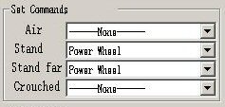

As you can see on this window Kim’s Power Wheel move can only be triggered while he is near or far from one opponent but not if he is crouched or in the Air.

Through the list fields you can open by clicking on the arrows, you can select the skill you want to assign on the command you are setting.

The Command Comp Options:
In the Command Settings, you can set which buttons, which motions, extra options and the time a npc will need to trigger this move.
On the left side you can see that there are two different settings.
The one is the image of one Arrow and the other is an E (End).
With the arrow fields you can open more slots for larger commands while with the E letter you can set the End of one command.
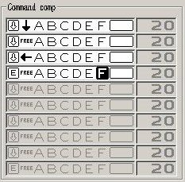
The Letters A to F corresponds to the Buttons Layout, which you can set individually on your keyboard.

FM2002 has as Default 6 buttons, which can be used for whatever you want to set as a command.
Those can be configured under the menu Option Keyboard or Joystick after you start or test a game.

You can also set those in the game.ini file but I wouldn’t recommend that.
Usually the buttons D to F are the upper layout and the A to C are the under layout.
You can see that also after you open the Keyboard and Joystick options as I mentioned above.

There was 3 Kanji Symbols in the Original Version of the Engine, which was partially translated into the English Language.
Those Symbols appeared in the field after the F Letter and the Command Time field.

As you can see on the Screenie, I put all the functions in a command together so that I can show you those on one image only.

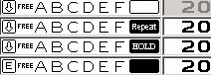

After you click on this field you will see that it hides some functions behind it.
Those can be accessed after you click on the field until they appear.

There are 4 different Settings you can make:

Blank (the white field without any function.)

Repeat
It means that you will have to tap repeatedly on the button.
It can be used for attacks like Chun Lis multiple Kick.

Hold
It means that you need to stay on the key the command is assigned on.
This setting can be used for Charge moves or Charge Attacks.

Black
Actually the third Kanji Symbol in the original.
The Black field can be used for attacks like Zangiefs 360 Degree moves.

The value in the last field on the right is an option that can be activated only if you use one of the options I mentioned above or by CPU related commands as a time factor.

In case of a Kanji Symbol relation, this field will count the repeating time, otherwise it will
stay inactive.

The CPU Pattern Window

In this Window you can configure and set the NPCs (NPCs = Non-Player Characters) Intelligence.

Due to those configurations you can set how often a NPC will use an attack and on what distance.

Also from what position of course!

Let’s take a closer look on the options of this window.
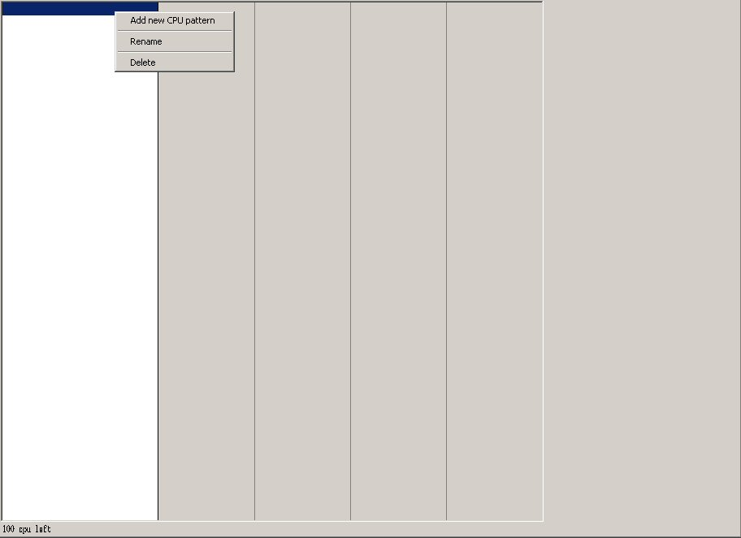

After you right click with your mouse on the white field on the left you’ll get the following options:

1) Add New CPU Pattern = You can create a new pattern by choosing this option.

2) Rename = You can rename an already created CPU Pattern with this one.

3) Delete = Erase an already made Pattern you don’t need anymore.

If you chose the first option a new window appears in which you can add commands and specify actions for your CPU controlled character.

In the screenie you can see the characters window on the left, the CPU commands which was added in the left middle, the conditions range bar in the right middle and the settings of the move which is marked on the right side.

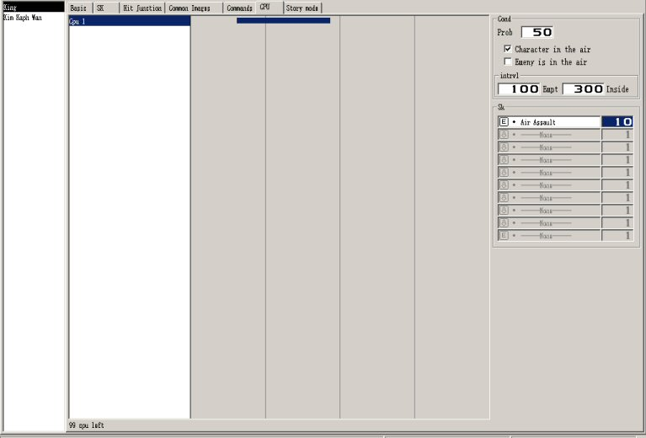

The CPU Window can contend 100 fields maximum.

That means that you can set, up to 100 commands for one character.

That gives you enough space for the commands you want your CPU player have.

The Conditions Options (Cond)

In the conditions Options you have the following fields:

1) Probability
2) Character in the air
3) Enemy is in the air
4) Interval
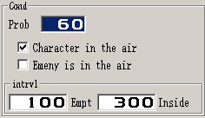
The Probability Field:
The value you will write in there will be the amount or percents of an attack occurring from a whole of 100.

If you set a skill on 0 then this skill will never trigger and the NPCs A.I. will totally ignore it while if you set it at 100 it will occur the whole time at the distance you give it under the Interval fields.

Character in the Air Field:
Check this option if the skill you are setting is an Air Skill so that the NPC will use it while in the air.

Enemy is in the Air:
Check this option if you are setting a skill that should be triggered while the enemy (Player character) is in the air or attacking with an air move.

The Interval. Fields:
In those fields you can add a value for the short and the long distance.

The first field represents the shortest distance a skill should trigger and second one, the longest distance.

The distance usable can vary due to the stage size.

Though the maximum size for the short distance is 9998 and for the longest 9999 what actually would be outside on any stage you made.

The Skills (SK) options:
In those fields you can set the skills the NPC should use by choosing them from the list by clicking in one field.

Depending on what a skill this would be you could set an amount of time on the second field.
As you can see on the screenie.

There are two settings on the left field, which actually extends (Arrow Icon) or ends (E Icon) the list so you can use more than one skill in this list (Combos) or only use one skill for a certain move.

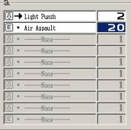
In the field you can set a motion by clicking on the Dots you can see on the screenie to change them to arrows as also can set a skill by clicking on the name (none or if you want to change one skill with a other one, the skill name).

In the time fields you can add a value, which will be the value the NPCs skill, will check before trigger the skill.
If this value is too high or too low it’s possible that the skill won’t trigger so it is recommended to give low values in low skills (like the light punch in the example above) and high values if it comes to special moves.

The same goes for combos when you are mixing skills together.

The Story Mode Window

The Story mode window includes many different options which gives you the opportunity to control the whole game like what kind of demos or other screens should be displayed before or after a battle, how many enemies should the player have in the next battle and so on…

First of all you’ll have to check the option Story Mode to be able to access the other menus

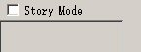

After that the grey list field should be open so that you can right click on it to gain access to the following options:

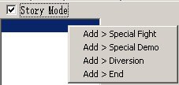

Add Special Fight:
Under this option you have the possibility to set-up a fight for the character you chose.

The Add Special Fight Submenus
You can gain access in those options after you added a Special Fight.

The Adv (Basic or Extended Story Menu) Tab:
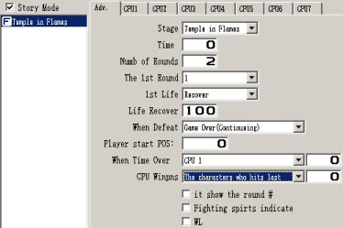

The Option Stage:
Set the stage you want the player to fight in here by choosing one from the list by clicking on the arrow right of the field.

The Option Time:
Set the amount of time for one round here.
The setting Zero is for Infinite time.

The Option Numb of Rounds:
Write the number of rounds you want to have for this fight in here.

The Option 1st Round:
This option counts the rounds you had together.

That means that if you had one round for this fight and this option is checked in every fight you set in your story mode, then all the fights will be counted together.

Though to make it work you’ll need to set a amount of rounds which has to be reached until the game ends like (Example), if you set 20 in your system script, then it will count until it reached 20.

I personally think that this option is good if you intend to have a counting system like in some games where you can see how many fights you had at the end of a game or a side scrolling Fighting Action Game like the Final Fight series.

The 1st Life Option:
Under this option you have two listings you can choose from:
The recover and the carry over.

The Recover setting:
The player recovers to the full amount of health on each round.

The Carry Over setting:
The player goes with the amount of health left to the next round.
This setting can be used for Survival or Fighting Action (side scrolling)modes.

The Life Recover Option:
The value of percent you write in this field will be recovered if the 1st life option is active.
Example: if you set it on 50 the player will recover only the half amount of life for the next round while it will fully recover if you set it at 100.

The Option when Defeat:
If you let this option to none, then the game will ignore the fact that you was defeated and go forward to the next fighting stage or demo on the list(except if you chose a path through the Conditions Junction mode).

If you choose Game Over Continuing, the game will go to the Continue or Game Over Demo (depends on your settings).

The Player Start Position Option:
Under this option you can set the players character Position at the start.
That means the value you will write in there will be the place on the horizontal line of the stage( X Axis).

The Option When Time Over:
Through this option you can set a winner condition in case that the time of a round is over while both players still have health points left.
To set a condition which lets the player with the most life points win, you have to set this option to Zero (0) otherwise you’ll have to write a value in the field in percents.
That means that if you add there 100 then it means the whole Health Points of a character, 50 would be the half and so on….

The CPU Winpns Option:
Probably another mistranslation but close to the right one.
You can use this option to set a win condition after the player lost all his/her Health Points.

To activate this option, you need to set a value in the field and chose a possibility.
The Value you add there is in percent (like described in the option When Time Over too).
There are three possibilities:

The Player = the player wins after he lost all his/her HP
The NPC(CPU) = the NPC wins after the player lost all his/her HP
The Character who hits last = the character who makes the last hit which costs the last Health Points of the Opponent wins(Default).

The It show the round # Option:
When checked, it shows the number of the round in the beginning of each round.
If not, then nothing will appear.

The Fighting Spirts indicate Option:
Actually it means the appearance of the “Fight” image for each round (mistranslated).
If checked the image Fight will show up, if not it won’t.

The WL Option:
If checked, then the stage will be like if there where invincible Walls.
That means that if each character is on the edge of their screen side, none will be able to “drop off” the screen or disappear in a other section of the screen where he/she isn’t visible anymore.

Example:
Your character makes a uppercut move which sends the opponent far up and away!

The Result if the option is checked:
The opponent will fall on the wall and then on the floor.

The Result if the option is not checked:
The opponent will go outside of the screen on the other side of the stage which is not visible to you (happens only by scrolling stages or large stages).

The CPU 1 to 8 Story Tab:

The Character Option:
Click on the down Arrow on the right of the field and select the character you would like to be the enemy of the player for this fight.

The Show Life Option:
It shows the amount(number) of life your character has as also displays a small life bar for that character in the Team Mode.

The Player Ignore Option:
If checked, the player won’t be able to hit this character.
This option can be used for Team Fights.

The CPU Level Option:
In this field you can set the NPC Difficulty by writing a number in the field.
The difficulty can be set from 0 (easiest) to 100 (hardest).

The Start Pos. Option:
In this field you can set the starting position of your character, by writing the number which would correspond to the position you want him/her to show up on the stage.

The Method Option:
The method option sets a condition for the appearance of a character.
It has three different settings which are:

Setting From 1st:
If you use this setting your character will immediately appear on the beginning of a fight.

Setting Time:
If you use this setting your character will appear after this value you set for time was reached.
This setting is good for the Team Mode as also for Special Intros.
Setting can be from 0 to 255.

Setting Life:
If you use this setting your character will appear after the main character has reached a specific amount of life.

That means that the engine will check the value you wrote in the field as a condition and if the requirement is meet, then the character will appear on the screen.

Notice that it won’t happen if your amount of life is equal ‘cause the condition looks if you are lower on life then the value on the field.
This setting is good for Team Modes, Tournament Modes and Side Scrolling action.

The Option Enemy:
The settings on this option can be:

Player:
If checked, the character you set this option will attack the Player.

CPU 1 – 7:
If checked, the character you set this option will attack the other NPC Characters.

Those two settings can be also combined, depending on the mode you are working on.
In a “normal” story mode, all the characters you want to battle with your fighter, should have the player setting only.

In a Team Mode, Side Scroller or Tournament Mode, you usually setting the Enemy NPC as attackable by your “friend” NPC while you would set the Enemy NPC on attacking the friendly NPC and the player.

The Victory Points Option:
On this option you can give a amount of points for the defeat of this character(Bonus).

It seems also as if this Option could be used to set a victory condition but since I didn’t used it yet I’m not sure if it’s possible to do so(also didn’t saw a other field where you can set more than 100 points or a points counting system except the Variables Check).

There are one list and one field you can set to do this.

In the list you have the settings:

Last attack given:
If you chose this setting, then the player who hits last will get the amount of points which you set in the field.

This usually means the winner in fight with the condition that if your character has no Life Points anymore he/she is defeated.

Otherwise it would check which players successful attack was the last one (last hit).

Player:
This setting is good for a Tournament a Side Scroller and a Team mode in which only your player character should gain points no matter if the enemy was defeated by a friendly NPC or the player itself.

CPU:
Same like the Player setting with the only difference that the NPC you set on the list (CPU 1–7) gets the points instead of the player.

The Option Effect:
Actually this option works together with the Victory Points option.
There are three settings available through one list and two fields.

The None Setting:
Let this default setting on if you don’t want to use this option at all.

The Last player who hits:
Works exactly like the setting Last attack given under the Victory Points Option with the difference that it will count the amount of energy and life set on the both fields in points (addition or Subtraction) like you know it from some fighting games as also Side Scrolling Fighting Games.
The Player Setting:
The same like the Player setting under the Victory Points Option with the same difference as explained under the Last Player who hits setting.

The Win Pause Option:
Another Mistranslation.
Actually this is the condition when this character is defeated.
It means that if its defeated, then due to the following settings he/she can Leave, Appear or Win pause (use the default Defeated condition.)

The Option When Time Over:
The value you set in the field will be the points you can receive after a time over.
Over the setting Player or CPU, the one who has been set for that will gain the amount of points.

Add Special Demo:
Under this option you can set a demo which should show at that time of the game you want it to like VS Demos for between the fights, cut scenes for your characters story and so on…

Just chose one of your added demos from the list on the right by clicking on the down Arrow to add one. This demo will appear then after the fight or whatever you added before it except if you have added a condition for it in the “Diversion” Option (Conditions Junction).

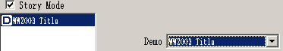

Add Diversion (Conditions Junction):
Obviously one of the mistranslated things in the engine.

In the Conditions Junction tab you can set conditions which can affect the way the character have to go through the story mode as also make extra stuff available to the player.

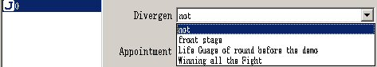

The Setting Front Stage:
Wasn’t able to find any use for this setting.

The Setting Life Gauge of Round before the Demo:
This setting will check the amount of life a player has left as a condition.
If chosen, then this option will check if the negative or positive value you set as a condition by writing a number in the field was meet.
If the condition was meet, then it will go to the demo or fight you appointed it to.
If the condition wasn’t meet, it will ignore the setting and go further to the next demo or fight you set before.
The Setting Winning all the Fight:
Through this setting you can set a condition which will go to the demo or fight you appointed it to only if you won all the other fights without using a continue.
Otherwise it will be ignored as a condition and will go further by default showing up whatever you added next.

Add End:
It ends the story mode at that point and makes sure you are going to the Title Menu again.

The Stages Creation Windows Explanation

The Stages Window has two sub- windows with which you can make your own stages.

To be able to use them you will need to right click on the white field at your left window so that the sub- menu appears.


The Add Stage Option:
This is the option you need to chose if you intend to make a new stage.

The Add Stage from File Option:
This is the option you need to chose if you want to add a finished stage in your project.

After you chose it another window will appear and you will be able to search and select the file from your Hard disk.

Those are the sub- windows of the Stage creation which will appear after you added a stage (new or from a file).

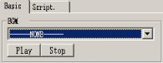

The Basic Window:
From this window you can select the music you would like to play on this stage.

To be able to do so, you need to add the music file in your script to make it appear on this list.

After you did that and selected the music for the stage, you can delete the added condition (S) from your script.

The Buttons Play and Stop are only for testing reasons and self-explanatory.

The Script Window:
In the Script Window you can add images, conditions, sounds, music and everything else you would like your stage you create to have.

On the top fields of a added skill (after you click on it) you can see the skill number and the image position.
The Skills works the same way like I explained on the Characters, so I will explain them exactly in the basic stage creation later.

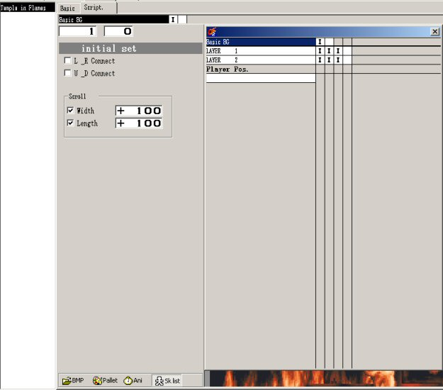

The Player Pos. Option:
This is one of the differences between the characters, demos and this skill window.
The reason this line is in there is because every skill you add over this line will be in the background of a character, while every skill you will add under it, it will be in front of the character.

The Initial Set Options:
Through the initial settings option, you can control the images positions and connections.

The L _R Connect Setting:
Through this option you can connect the left and right side of a image together.
This way the image will repeat itself and look as if it would be a whole.

Note: To look right it should be a image which really can be connected through the things on it on the left and right side, otherwise it would look weird.

The U _D Connect Setting:
The same effect like the L R Connect setting with the difference that it will connect the upper with the down section.

The Scroll Option:
The Default setting of a Stage in the engine is 640x480.

So if you have the following settings unchecked (off), the then stage size will be as default.

The Setting Width:
Through the value you add in the field, you can set the size and scrolling speed of an image you added in your stage in width(The X Axis).
The Value you add affects partially the walking speed of a character on this stage.

The Setting Length (Height):
Through the value you add in the field, you can set the size and scrolling speed of an image you added in your stage in Height(The Y Axis).
The Value you add affects partially the jumping speed of a character on this stage.

The Demos Creation Windows Explanation
On this window you can create you Title, Select, Versus, Continue, Game Over Credits demos as also Cut- Scenes and special demos you want to have in your game.

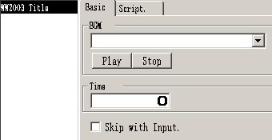

Adding a Demo from a file or Adding a new Demo, works exactly the same like we said before in the stages section.

After you added a demo (no matter new or from a file), the following windows will appear:

The Basic Window:
This window is almost the same like the one under the Stages section with the difference of two more options.

The Time Option:
The value you will write in this field, will be the time the selected Demo will be displayed.
If you let the field empty (value zero), then it will play endless repeating itself, until the player taps on a button(only works if the Skip with Input option is checked) or if there are options which can be chosen to go further like in a title, select or continue screen.

The Skip with Input. Option:
If this option is checked, then it will trigger after you tap on one of the keys you set as your keyboard configuration.
This option is good (and highly recommended!) for opening demos which are good to see the first time but only bothers after since nobody wants to see the intro every time he/she starts a game.

The Script. Window:
Almost the same like the stages script window with the difference that there are no settings available under the Initial Set and instead of the Player Layer option there is a Game Script Option which has the same function like the Player Layer under the Stages.

With the only difference that it’s meant that the added skills after the Game Script (instead of Players Layer)skill will cover or appear in the front of the skills above it.
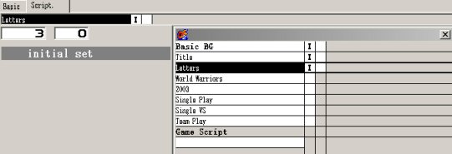

Conditions & Functions Explanation

In FM2002 are different Conditions and Functions available.
Those are needed for the different skills in the creation of a game system (also called script), a stage, character, demo or extra things.

I will list them all and explain their functions here while I will show you examples in the basic and advanced creation tutorials after.
This list should only give you a idea about on which cases you could use them and also show you what they could or couldn’t do.

The I Function:
Through the I (Image) function you can add images, set their appearance time as also adjust the width and height of where the Image should appear on the screen(Position).
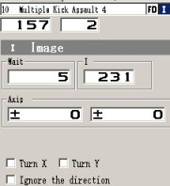
Through the Turn X and Turn Y options you can Turn the way a Image shows. If the Ignore direction Option is checked, then the Image will look always on the side which was set before. If not, then it will turn in the right direction.

The M Function:
With the M (Move)Function you can set the amount of speed and gravity for the X (Left or Right) and Y (Up and Down) coordinates.
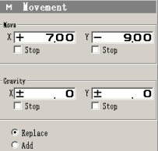

You can add a positive or negative value in one of the fields depending on what you want to do.

The Replace Option:
Through this option you can make the values you wrote in the Speed and Gravity fields
not replaceable. That means that those values won’t change at all.

The Add Option:
Through this option you can make the values you set in the Speed and Gravity Fields to add the value written to themselves. That means that the values will get higher according on the number you set, every time this move occurs.

The FD Function:
The FD Function is one of the main needed function.

You can use it in every time you need something to react after a collision (Hit Junction).
To make it work right, you will need to know how to use it as also what every setting actually does.

The M.Number Setting:
This setting makes you able to have maximum 9 different FD in a skill without to replace one of them.
To be able to do that you will have to give them the numbers 0 to 9.

If two FD sharing the same layer(as example 0) in the same skill, then the latest one will replace the previous one.
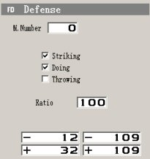

The Striking Setting:
If checked, you will be able to create a hit junction around a character or a object which would prevent, that by a collision a character or a object can be passed through a other.

The Doing Setting:
If checked, you will be able to create a hit junction around a character or a object.

This Hit Junction would allow the character or the object to get damage but will also allow a character or object to pass through it.

The Throwing Setting:
If checked, you will be able to create a hit junction around a character or a object which would allow the character to be thrown and get damage through this throw.

It will also allow a character or object to pass through this one.
The character or object won’t get any damage through strike attacks on this setting.

The Ratio Setting:
In this field you can set the amount of damage a character or object can take through a hit.

The Default Damage setting is 100, the maximum Damage is 255, if you set it at Zero, the character or object won’t take any damage.

The FA Function:
Also one of the most used and needed Functions in the Engine.
If you want to give damage to anything you need this Function (together with the FD and the R of course).

You can set different conditions for different situations through the available options.
Those would occur by a collision of a character or object with the character or object you set this FA.
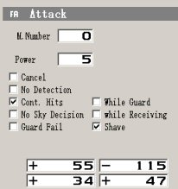

The M.Number Setting:
This setting has exactly the same purpose as the one I explained on the FD function.
.
The Power Setting:
The Value you will set in this field, will be the amount of damage the enemy will take if he/she gets hit by this attack.

The Cancel Setting:
If checked, it makes this attack cancellable after a collision (depends partially on the other settings too) between two characters or objects has occurred.

The No Detection Setting:
If activated, then it will prevent the attack from hitting through Detect Skill Functions.

The Cont. Hits Setting:
If this Function is checked, then this attack will add it’s hits to the previous ones and gives out the result as a whole.

As example: 2 hits from the previous attack + 2 hits from this attack gives the result of 4 hits).

The No Sky Decision Setting:
It prevents the attack from dealing damage to characters and objects while they are in the air.

The Guard Fail Setting:
Through this setting you can make unblockable attacks.
That means that a attack which contents a setting like this, is only avoidable through a dodge or a jump.

The While Guard Setting:
Through this setting you can make this attack to hit only while the object you are attacking is Guarding(Blocking).

The While Receiving Setting:
If checked, then this setting will make the attack trigger only if a previous attack has hit the enemy character or object.
The Shave Setting:
It checked this setting gives damage to a blocking opponent by penetrating the block.
The amount of damage depends on the value you set in the field.
If unchecked, then the attack won’t give any damage to a blocking opponent at all.
The 4 fields under the settings are the coordinates fields, which hold the X – Y values of the attack frame you draw over the character or object you wanted to have it.

The R Function:
In the Reaction Function you can set the hit junction skills you previous made for a character or object so that in case of a collision of your FA frame with a other object, the collision detection “knows” which skill in which stance should be triggered as also which skill on which stance can guard it.
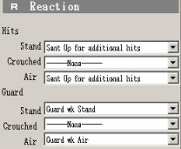

It contents the list fields Stand, Crouched and Air for both Hit (when the object got hit by a other one in one of those stances) and Guard (on which Guard Stances can this attack be blocked).

The S Setting:
Through this Setting you can add sounds in your skills!
After you added one sound by clicking either on the WAVE, MIDI or CDDA (Music CD Track actually) and selecting the file from your Hard Drive, all you need to do is select this file in the list. If you want it to repeat after the file reached its end, just check the Loop to point option.
You can test your selected file by clicking on the Play button and can stop it again through the Stop button. To delete the selected file, just click on the Delete button.
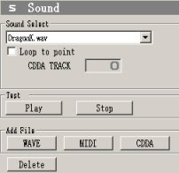
The Cancel Condition:
Through this condition you can cancel super moves on each other, make special combos or set special cancellations for different situations.

The Setting Fail (Failure):
Through this setting your skill won’t be cancellable at all.

The Setting Hit:
Through this setting you can set the skill this condition is set for to be cancellable through a successful hit.

The Setting Uncod.(Unconditional):
Through this setting, the skill which is set for will cancel at the time a command was executed.
You can also combine this setting with the Cancel Condition setting which will be explained under this one.

The Cancel Condition Setting:
In those fields you can set a Cancellation condition by writing the number for the lower value on the left field and the higher value in the right field.

That means that the range between those both values will be considered and a cancellation will be triggered after the required value was meet.

Through this Cancellation method you can link skills into each other or make skills be cancellable only by certain skills.

The Skill Setting:
In case of a cancellation the skill was chosen in this field will be triggered.
That means that if you launch the skill which you chose in this field, then your previous skill will cancel into that one only.

Modification function in FM2ND is too basely change the color or layer effect for an image. It is included throughout most of the tabs in the editor.

The Colour Option:
Through those settings you can make a image in the skill appear in a other Colour then it’s default one.

The Normal Setting:
No modification on the colour of the image if you chose this setting.

Mostly used to reverse modifications which was made before in the same skill.

That means that if you used one of the other modifications for a image in a skill, you can change those modifications back to their default colour by using this setting or to set a other colour after you changed it by using the R,G,B fields as a default for this skill.

The 50% + 50% Alpha Setting:
If you set a modification like this, the image affected by it will have 50% opacity.
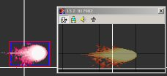

The A + B Addition Setting:
This Setting gives your image a layered effect by raising the colours of a image through addition.
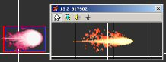

The A - B. Subtract Setting:
This Setting “drains” (Subtracts) the colours of a image leaving it totally black.
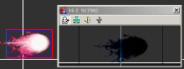

The A - B Alpha Setting:
Through this setting you can raise or decrease the opacity of a image(activates the A field under the colour settings and makes you able to give it a opacity value in percent).
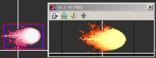

The Colour Settings:
There are four fields which makes it possible to modify the appearance colours of a image as also it’s opacity.
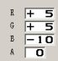
In this field you can increase or decrease the amount of the Red colour in this image.
In this field you can increase or decrease the amount of the Green colour in this image.
In this field you can increase or decrease the amount of the Blue colour in this image.
In this field you can increase or decrease the opacity of the image.

The Object Function:
With this Function you are able to make active objects in your skills for either appearance or/and interaction purposes.
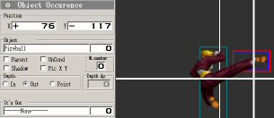

The Position Setting:
Through this setting you can control the position of the appearance where the image should show up by setting it’s X and Y coordinates.

To set those just add a value in the fields and increase or reduce the value or just click on the object and drag it around until you reached the position needed.

The Object Settings:
Object = chose the Skill which includes the object you want to use from the list by clicking in the field.

Parent = the objects reactions will be timed to the skill which the object should appear to.

Uncond (Unconditional) = The object will ignore the main skills settings and will appear where you set it as it is.

M.Number = Through this field you can set a number for your image.
Available numbers are from 1 to 9.

This function prevents the replacement of a image in case that you want to use the same image multiple times in the same skill.

Shadow = The Object will have a Shadow itself.
This setting is mostly used for strikers or available partners of your character like (example) Nakorurus Wolf and Hawk.

Pic X Y = This field allows you to set your object according the default coordinates a stage is using (640x480).

In = Through this setting the object will appear behind your character.

Out = Through this setting your object will appear in front your character.

Point = Through this setting you can set your object according the value you will add in the “Depth Ap” field.

The It’s out Option:
In this option you can set a skill in which the character (or anything else) you have set this object will trigger after the main object was launched.

That means that if you have a character doing a fireball, after he/she launched the fireball, he/she will change to the skill you set in the It’s Out field and do whatever you set it to do for a few seconds.

In the field right of the skill list of the It’s Out option, you can set a time from 0 to 18.

This is the speed the animation you chose in it’s out will play while 0 is the lowest speed and 18 the fastest.

The Condition Fork Functions
The Condition Fork Functions are listed as seen on this Screenie:

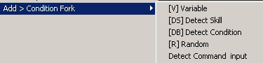

The Variable Function:
It seems that many people have problems to understand how a Variable works or what it is so I will explain the way I learned it when I was learning Programming (C+, Visual Basic, Cobol, Basic, C++) in the past.

A Variable is actually a Value holder in a Number or a Letter format.
That means that you can set the letter A as a Variable and give it a value.
This value you gave it can be used to make additions, subtractions and so on….

Example:
We give the A Variable the value 1. That means that A=1.
This letter holds this value and gives us the chance to use it to count conditions or to check conditions like the following:

IF A = 2 then a attack should be performed by the fighter (Variable check).
Since we gave A the value 1 in the beginning it doesn’t meet the condition so the attack won’t trigger and the fighter won’t do nothing.

To change that and make the attack trigger we have to add 1 point to the Variable A so that can meet the condition.

That means that we have to give to Variable A + 1 to make it have the value 2.
That would make the Variable A hold the number 2 (A=2).

To do this we have to set a Variable condition somewhere in a skill we want to use for this condition which would add this 1 point to our A Variable so that our Variable will hold the number 2 in it.

After we done that, the next time our attack will make a check on the A Variable, it will meet the condition see that it holds the number 2 and will launch the attack.

I tried to explain this as simple as possible so that everyone can understand it.
In case that you still didn’t, I would recommend you to check some books or search the internet about any learning sites where you can learn variables.

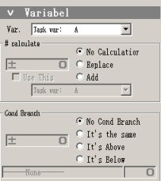

The Var Option:
Through this list you can set the Variable you want to use for this skill.

There are 3 different possibilities:

The Task Variable:
A Task variable can make counts or checks for this particular skill you set it only.

The Character Variable:
A Character Variable holds values which can be used for the whole character you are using them for, no matter in which skill you set it.

The System Variable:
A System Variable can be used for conditions which affects the whole system (game script checks, character checks, stages checks, demo checks and more…).

The Calculate Option:
In this field you can add the Value you want your Variable to hold to in case that you want to make additions or/and subtractions.

The No Calculation Option:
If checked it deactivates the Calculate Option.

The Replace Option:
If checked then the Value you set in your Variable will be replaced through the new Value you added in the Calculate Field.
You can also check the “Use This” Option to add in this Variable the Value of a other Task, Character or System Variable.

The Add Option:
The Value you set in the Calculate field will be added or subtracted to the Value your Variable already holds.
You can use the “Use This” Option the same way like explained under the Replace Option above.

The Use this Field:
If checked then you can select one Variable which should replace or add/subtract it’s value to the one you have checked the field.

The Cond Branch Options:
Under the Condition Branch you have different settings which you can use for your variable.

The No Cond Branch Setting:
If checked, it means that this Variable is unconditional and want use any setting of the Conditions Branch.

The Its the same Setting:
If checked, it will compare the Value in the Cond Branch field with the Value of the Variable selected.
If both Values have the same amount, then the skill you set to trigger will be launched.

The Its Above Setting:
If the Value is bigger(higher Value) then the Value of the Variable you selected, then the skill you set to trigger will be launched.

The Its Below Setting:
The same like the It’s Above setting with the difference that the Value has to be lower then the Value of the Variable selected.

The Detect Condition [DS]:
In the Detect Skill Condition, you have 7 different settings you can use to make a skill trigger only if the requirement you set in the DS is meet.

Through the Upper field you can select a condition.
In the lower field you can select the skill which should be triggered if the condition is meet and in the small field you can see the number of the skill you selected.
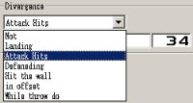

The Setting Not:
This setting deactivates the Detect Skill Condition.

The Setting Landing:
When selected, the character will go to the skill selected while the Landing skill is active.

The Setting Attack Hits:
After a set attack hits, the DS will trigger the selected skill.

The Setting Defending:
If the attack gets blocked, the skill selected will trigger.

The Setting Hit the wall:
After a character got a hit which made him hit against the stage walls, then the skill selected will launch.

The Setting In offset:
If the character you hit got two hits with a successful offset(space between two hits) in between, then the selected skill will trigger.

The Setting While throw do:
If your character made a successful grab attack then the selected skill will trigger.

The Detect Basic Condition Setting [DB]:

The its not:
If selected it deactivates Skill Detection.

The Guarding Setting:
If this setting is set, then it will check if the character is on the floor.
If this and the Call Ahead requirements are meet, than the skill selected will be called.

The Standing Setting:
If this setting is set, then it will check if the Standing skill is active.
If this and the Call Ahead requirements are meet, than the skill selected will be called.

The Crouching Setting:
By this setting you can check if the character is in the crouching skill.
If this and the Call Ahead requirements are meet, than the skill selected will be called.

If forward is tapped:
It makes a check of the directional key you used for the skill forward forward.

If Back is tapped:
It makes a check of the directional key you used for the skill Backward.

If is Up tapped:
It makes a check of the directional key you used for the skill Jump.

If Down is tapped:
It makes a check of the directional key you used for the skill crouching.

The Call ahead Option:
This option has two different settings.
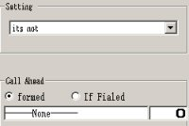

The Formed setting:
Makes a check to the setting you use.
If the setting is meet, then it will trigger the skill you set in the field, if not it will ignore it.

The If Failed setting:
Makes a check to the setting you use.
If the setting you made will fail, then it will trigger the skill you set in the field, if not it will ignore it.

The Random [R] Function:
The Random function can be used to make a count of a skill and change the skill if the requirements are meet.

This Function contents 3 fields:
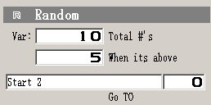

The Fields:
Actually with Var: it should mean Variation of a Value.

The amount of the Value you add in the field as Total #’s, gives the default variation you can compare with the field When it’s above.

As you can see in the Screenie the Total contents a value of 10 while the When it’s above contents the Value 5.

That means that IF the skill you selected in the skills field has a value between 5 and 10 which is higher than 5, THEN the skill in the field will trigger and your character will act like in the skill selected.
IF NOT, THEN it will go forward and launch the actual skill you set the Random Function in.
In the small field on the right you can select in which position of the skill selected you want the skill trigger by chose the number( in this case a 0 since I want it to play from the beginning.).
The Detect Command Input Function:
This function makes you able to trigger skills after another through a command relation which connects both with each other, like the (Example) 3 quarter circles move from Iori in the KOF Series where he performs three different strikes through a series of commands you have to input with your Gamepad.

In the Command Field you can select a skill you want to launch in case that the command will be triggered by doing the motion you set in the command buttons field.

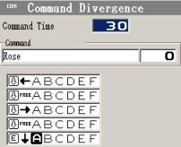
In the Command time Field you can set how much time is available to do this command.
The higher the value, the more time you have to do the command you set .

The Script Movement Options
Under the Script Movement Options are 3 different Functions you can use for movement related conditions.

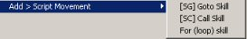

The Go to Skill Function:
This Function can be used to change from one skill to another if a condition is or is not meet.
You can also use it to move from one skill to a other after the previous one is finished.

The Call Skill Function:
This Function can be used in a skill which needs other skills to be launched before the main skill ends.
It’s mostly used in special skills or character related super moves.

The For (loop)Skill Function:
Through this Loop Function you can make a skill repeat itself.
Under the Call ahead Field you have to select the skill which will be called and under the Loop field you have to set a amount of times this skill will be performed by setting a value.
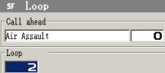

The Successful Partner Hit Management Options
Through those options you can set different conditions and reaction for the enemy character in cases like throws or super moves where you want the enemy to be in a position or a stance you want him/her to show up to.
There are two different settings you can pick from.

The Change Shape's Condition Condition [RC]
This particular condition can be used mainly for throws or super moves which require the enemy to be in a specific stance.
As also for items and other stuff you would like your players to react to.

This Condition has the following settings:
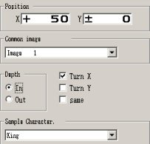

The Position Setting:
Like many similar settings in our engine, the position setting helps you place a image in the right position on the screen by using the X – Y coordinates fields.

The Common Image Setting:
To be able to use this field you will have to add the common images in your game scripts common images window.

After this, there will be a list where you can chose one common image for this skills condition by clicking on the down arrow key to open it.

The Depth Setting:
You can choose for the common image to be behind (in) or in front (out) of the character.
5 Different settings here while you can combine those.

The In & Out Settings:
If you checked the In setting then the common image selected will appear in the background while if you check the Out setting it will appear in front of your characters image.

The Turn X Setting:
It changes the direction of the common image to the opposite(Mirroring) from left to right and vice versa.

The Turn Y Setting:
It changes the direction of the common image to the opposite(Mirroring) from up to down or vice versa.

The Same Setting:
Actually I couldn’t find out anything about this setting because no matter what settings I change nothing happened to the image or anything else.
It might have to do something with the reactions but since I’m not sure if it really does I will let it be as it is.
All in all the importance of this setting doesn’t seem to be high anyway.
It could had been a mistranslation too.

The Sample Character Setting:
This setting helps you by the positioning of the common image and the use of the other setting by giving you the opportunity to select one of your characters for testing purposes like in the Screenie.
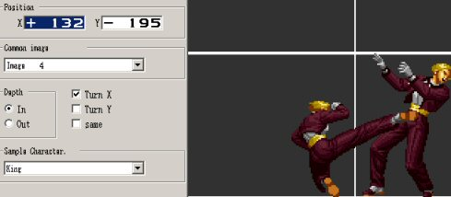

The Change Skill Function [RP]:
It contents a few settings which helps a lot in cases in which you need to change the hit junction of a attack in a move without to have to add another Reaction[R] and Attack[A] every time.

The only thing that this function misses is the image visibility.
To be able to see the hit junction Image and be able to position it properly, you will have to open the animation window and position then your image under the RP Skill settings Position.

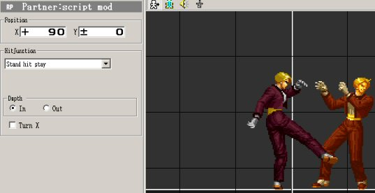
The Position Setting:
This Setting helps you place a image in the right position on the screen by using the X – Y coordinates fields.

The Hit Junction List:
Through this list you can chose and set one of the in the script available hit junctions you would like to trigger.

The In & Out Settings:
If you checked the In setting then the common image selected will appear in the background while if you check the Out setting it will appear in front of your characters image.

The Turn X Setting:
It changes the direction of the common image to the opposite(Mirroring) from left to right and vice versa.

The Gauge Options
Over the Gauge Options you can manipulate the amount of the Lifebar and Powerbar your character uses in a game.

The Gauge Options contents 3 different settings.
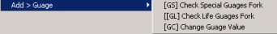

The Check Special Gauges Fork[GS] Function
This Function allows you to check the amount of Powerbar your character has and trigger a skill if the requirement meets or move to a other skill in case that it doesn’t.

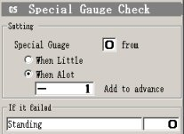

The Special Gauge Settings:
The field From, holds the amount of Powerbar you would like to make a check on.
It can hold the numbers 0 to 9 while every number represents one level of a Powerbar.

The field When Little makes a check on the From field and compares it’s value with the remaining powerbar. If the Powerbars value is less the value in the From field then the skill will consume or add the amount of levels in the Add to advance field of the powerbar and launch the skill. If not, then it will move to the skill you picked up in your If it Failed Skills list field.

The field When A Lot works the same way with the only difference, that it will check if the value is higher than the amount of your Powerbar like the example on the Screenie.

The Check Life Gauges Fork[GL] Function
This Function allows you to check the amount of Lifebar your character has and trigger a skill if the requirement meets or move to a other skill in case that it doesn’t.
The lowest value you can set is 0 while the maximum is 1000.
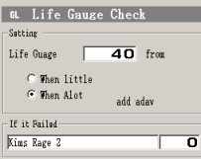

The Life Gauge Setting:
Add the amount of life you want to have checked in this field.

The When Little Setting:
If checked, the condition will compare the amount of Life you added in the field with the amount your character has left in his/her Lifebar.

If Lifebar will have higher Value then the Value in the Life Gauge Field, then the skill will trigger, if it doesn’t, it will go to the selected skill you set in the If it Failed Field.

The When A Lot Setting:
The same like the When Little setting with the difference that it will check if the Value in the field is Higher then the one in the characters Lifebar.

The If it failed Setting:
In this field you can set the skill you would like your skill to go too in case that the “When” conditions mentioned above fails.

The Change Gauge Value Function [GC]
With this Function you can increase the Values of the characters Lifebar and Powerbar through addition and subtraction which you can set in the fields Yours for your character and in His for the enemy.
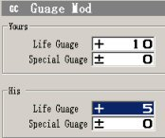

The Special Effect Option
There are three Functions under this group which gives you the opportunity to add some good effects in your skills.
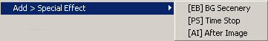

The BG Scenery Function[EB]
Through this Function you can make a Effect which would affect the Stage, players or a system event while a skill which contents this function triggers.

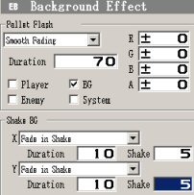

The Pallet Flash:
After you click on the list field, you can chose one of 4 different settings.

The Unused Setting: turns this function totally off.

The Smooth fading: will make the stages BG fade until the skill reached the amount 0 and all it’s black.

The Chika Chika fading: will make the stages BG blink.

The Random: Will use one of the other functions I mentioned above.

The Field Duration:
Add the amount of time you want the effect to take place in there.

The RGBA Fields:
R = “Holds” the amount of Red Color in the effect (increasing or degreasing with + or -)
G = “Holds” the amount of Green Color in the effect (increasing or degreasing with + or -)
B = “Holds” the amount of Blue Color in the effect (increasing or degreasing with + or -)
A = “Holds” the Opacity of the Colors in the effect (increasing or degreasing with + or -)

The Player Setting:
If checked, then the Effect shows up directly on your Player.

The BG Setting:
If checked, then the Effect shows up directly on your Stage.

The Enemy Setting:
If checked, then the Effect shows up directly on the Enemy Player.

The System Setting:
If checked, then the Effect shows up directly on system related event which could be anything around your stage.

The Shake BG Options:
The Shake BG options contents 6 fields you can add values in:

The X and the Y Fields:
There are 3 settings which you can pick one from for those both fields.
The Fade Out Setting:
The shake will be reduced at the time the duration expires.
The Value for the Duration Field will determine for how long the shake will take place while the Value in the Shake field will determine how strong the shake of the screen will be.

The Fade In Setting:
The shake will be increased at the time the duration expires.
The Value for the Duration Field will determine for how long the shake will take place while the Value in the Shake field will determine how strong the shake of the screen will be.

The Fixed Shake:
The shake will stay as it is for the duration time given.
The Value for the Duration Field will determine for how long the shake will take place while the Value in the Shake field will determine how strong the shake of the screen will be.

The Time Stop Function [PS] (Player Stop)
With the time stop function you can let your characters and object as also the opponent characters and object freeze for the amount of time you need to by setting one of the two conditions available.

The Your Time Condition:
The Value you will add in this field will be the amount of game time your Character/Object will freeze while the Game Clock will continue to count.

The His Time Condition:
The Value you will add in this field will be the amount of game time the enemy Character/Object will freeze while the Game Clock will continue to count.

The After Image Function [AI]
With this Function you can add some movement effects in your characters and objects.
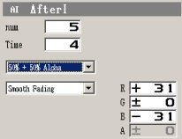

The Num (Number) Field:
You can set the amount of after images you would like to appear by giving it a value from
0(None) to 100(Maximum).

The Time Field:
You can set the amount of after of time the images you set in the Num Field will appear on the screen by giving it a value from 0(none) to 255(maximum time).

The Normal Setting:
No modification on the colour of the image if you chose this setting.
Mostly used to reverse modifications which was made before in the same skill.

That means that if you used one of the other modifications for a image in a skill, you can change those modifications back to their default colour by using this setting or to set a other colour after you changed it by using the R,G,B fields as a default for this skill.

The 50% + 50% Alpha Setting:
If you set a modification like this, the image affected by it will have 50% opacity.

The A + B Addition Setting:
This Setting gives your image a layered effect by raising the colours of a image through addition.

The A - B. Subtract Setting:
This Setting “drains” (Subtracts) the colours of a image leaving it totally black.

The A - B Alpha Setting:
Through this setting you can raise or decrease the opacity of a image(activates the A field under the colour settings and makes you able to give it a opacity value in percent).

The Fixing Setting:
This setting will make the after images appear without a blink or fade effect.

The Smooth fading:
This setting will give the after images a fading effect.

The Chika Chika fading:
This setting will make the after images blink.

The Random: Will use one of the other functions I mentioned above.

The RGBA Fields:
R = “Holds” the amount of Red Color in the effect (increasing or degreasing with + or -)
G = “Holds” the amount of Green Color in the effect (increasing or degreasing with + or -)
B = “Holds” the amount of Blue Color in the effect (increasing or degreasing with + or -)
A = “Holds” the Opacity of the Colors in the effect (increasing or degreasing with + or -)

Credits

Special Thanks goes to:

ASCII & Enterbrain for the programming & distribution of this wonderfull Engine.

Proof 58 for the Translation in the English Language.

Kingkooler, Maglauncher, Gamma and Punisher for starting this community with me 4 Years ago!

Every Creator who ever was and those who still are in our Community!
Without you guys this community would be a empty cell. ☺

To everyone who ever contributed in this Engine and this Community.

Last but not least:

A Big Thanks to all of those who ever believed in me and stood by my side no matter what stroke our community or not!

I love you guys you are the best! ☺

Info

This document is protected from changes so if you think that something I wrote is wrong please feel free to correct me by sending a mail at: fm95master@hotmail.com
If you try to make changes yourself then the entries will mess up so please don’t do it!

